George Cummings
george.cummings1@gmail.com
Title: SDG14 Ocean Ambassador
Affiliation: Mission Blue WFCRC
Bio:
UN Volunteer SDG14 Ocean Ambassador
Proposed to UNESCO SDG14 Citizen Science Diver initiative 1,000 Science divers survey 1000 dive sites Decade Ocean Science. 33 years global Ocean science observations the problems and solutions. 25 years DEMA, largest global pro diving tradeshow, work on Ocean solutions, all aspects for the planet. Now focused on establishing UNESCO Center for Excellence "Save the Meso" world’s 2nd largest reef system.
1993 1of3 creators SXSW Interactive, technology, and GOOD come together.
2016-19 advisor EarthXOcean summit
2018 co-founder Inland Ocean Coalition Austin TX,
30+ years diving Cozumel N end MesoAmerican Reef, 2017 working with local science, government, education, business to deploy SDG14 solutions.
Giving Back So Future Generations Might Have An Ocean too.

George Cummings
SDG 14 Ocean Ambassador
Mission Blue Project Partner-World Federation Coral Reef Conservation
Austin, TX
512 750-9605
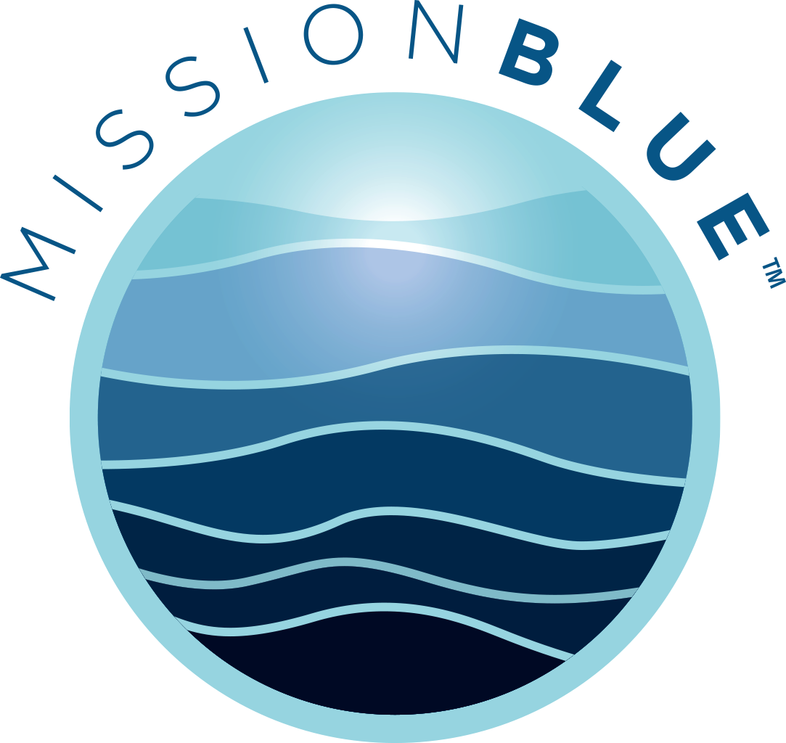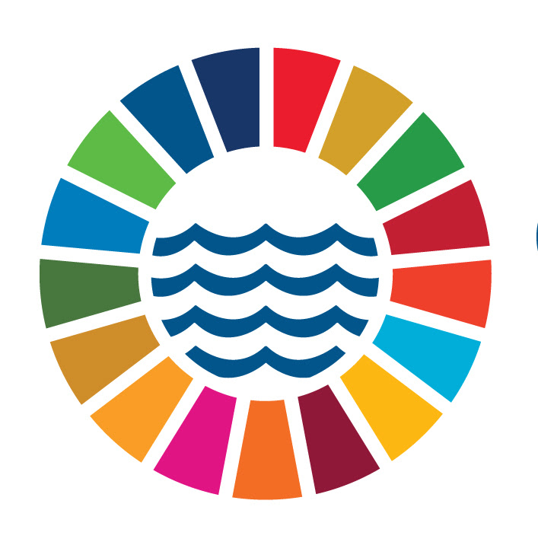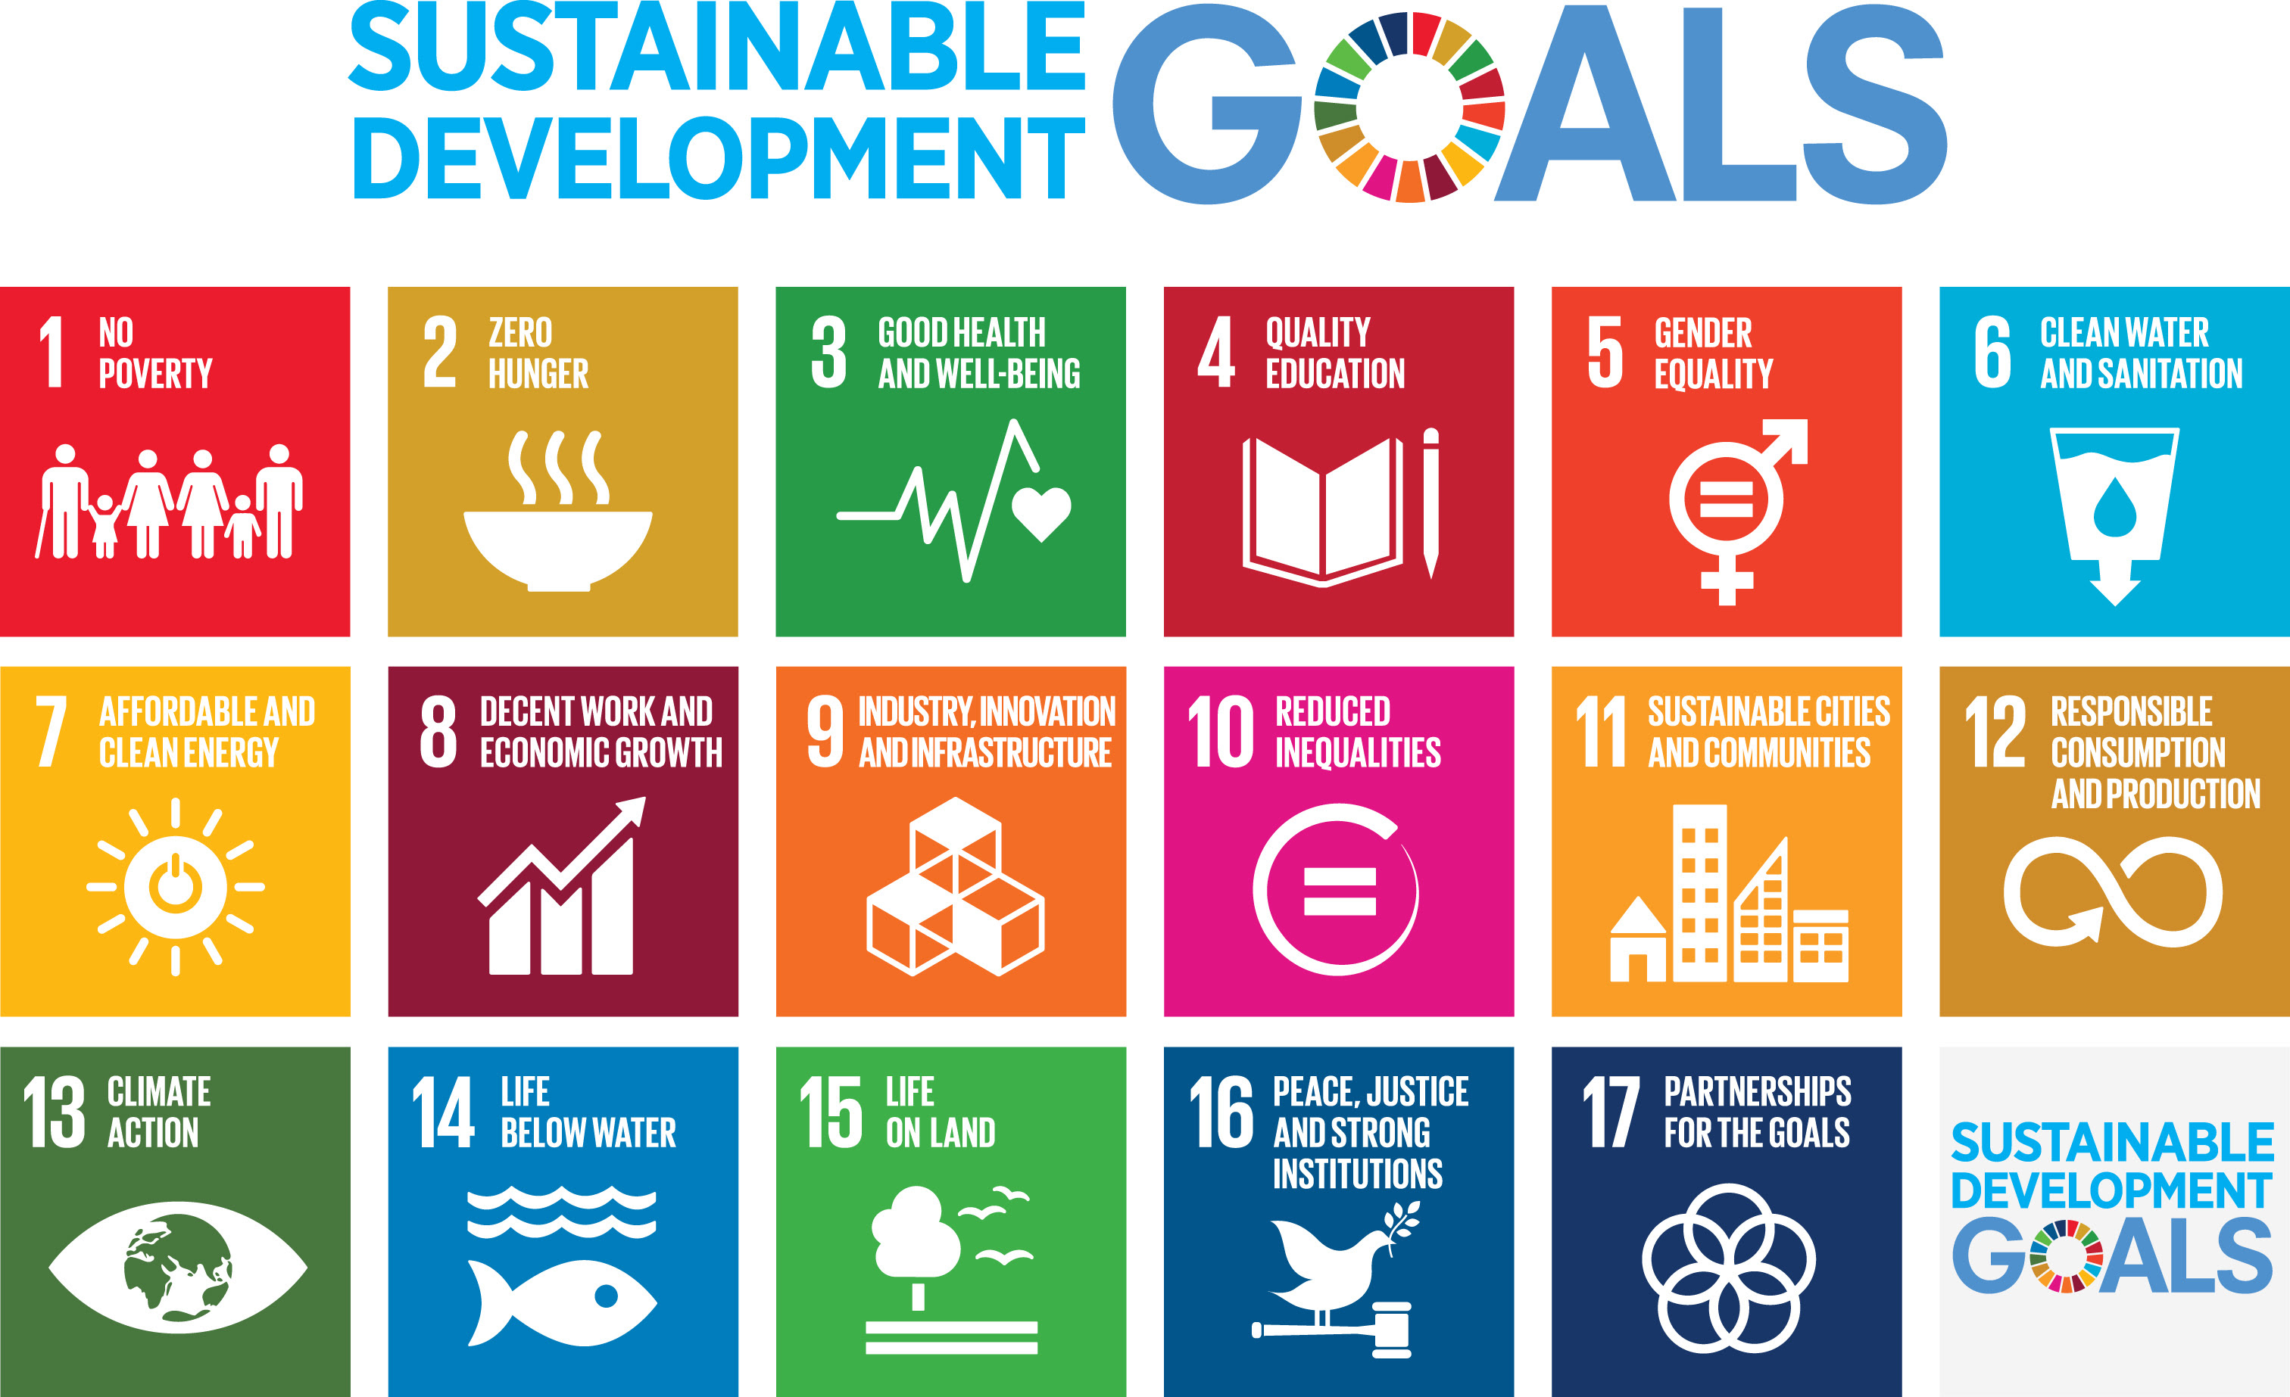
www.wfcrc.org

